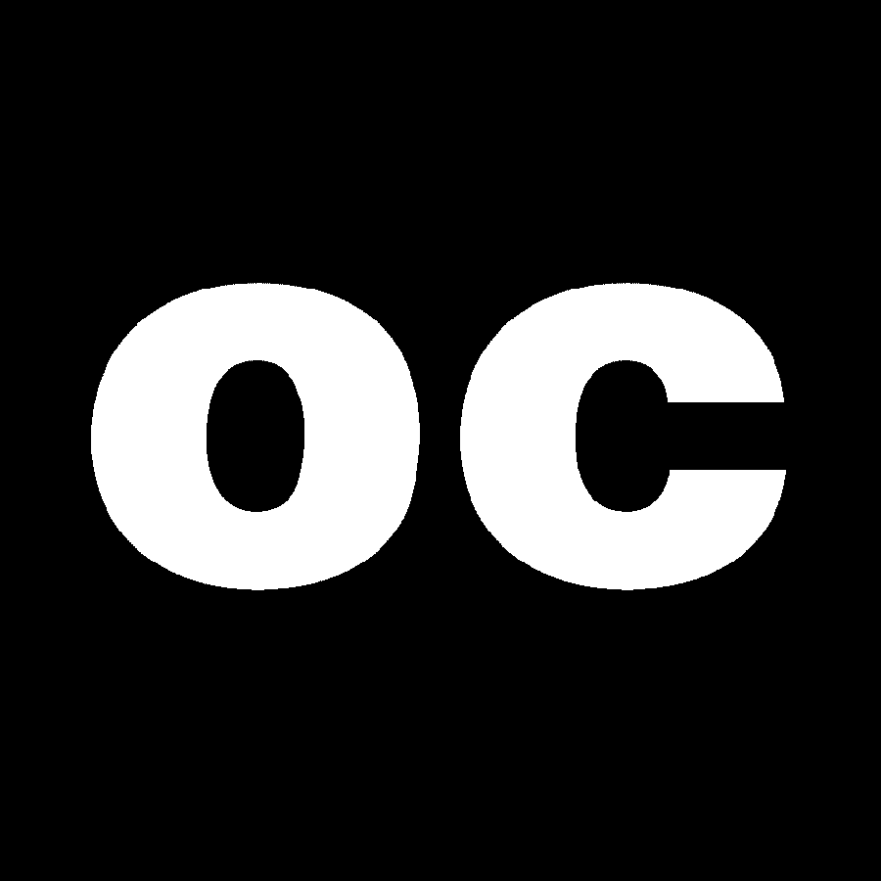
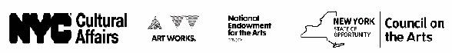
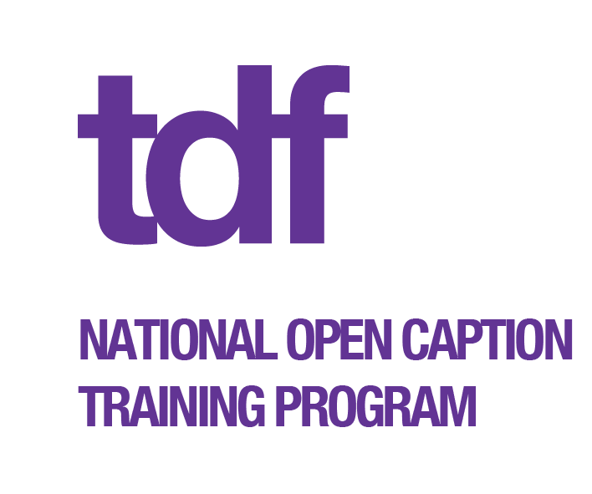

Don’t Miss These Upcoming Open Captioned Performances!
[insert upcoming performances here]

c2 Inc, a 501(c)3 nonprofit company, pioneered professional Live Performance Captioning™ for theater and cultural events and is nationally recognized as the leading authority in the field. Celebrating its 14th anniversary of open captioning in live theater, c2 continues its mission to expand services throughout the United States, and already boasts an impressive roster of prestigious venues now offering this vital access program. c2 is very proud of its long-standing alliance with TDF and its role in making the Broadway OC initiative the most successful program of its kind. c2 is co-founded by David Chu and Donald DePew. www.c2net.org
Open captioning is a service for people with hearing loss that uses a text display to provide a simultaneous translation of dialogue and lyrics during a live performance, as well as a description of any sound effects on stage. The service is open to everyone for viewing in a designated seating area without any special equipment needed by the audience member. Since first introducing the service to Broadway in 1997, TDF has sold over 65,000 tickets to open captioned performances.
This open captioned performance is presented by TDF.
TDF Accessibility Programs (TAP) wish to acknowledge the producers, cast, crew and theatre staff of for helping us to welcome you to the latest offering of open captioned performances which are presented on Broadway, Off Broadway and in regional theatres across the country.
TDF sustains live theatre and dance by engaging and cultivating a broad and diverse audience and eliminating barriers to attendance.

TAP is an accessibility department within TDF. Since 1979, TAP has sought to make theatre accessible, enjoyable and affordable to people with disabilities. TAP services include open captioned, sign language interpreted, audio described and autism-friendly performances. TDF’s National Open Captioning Training Program partners with performing arts groups around the country to provide open captioning for their local audiences. For more information about TDF and its many programs including TAP and National Membership go to: www.tdf.org

TDF is grateful for the generous public and private support which make TAP possible. This program is supported, in part, by public funds from The New York City Department of Cultural Affairs in partnership with the City Council, National Endowment for the Arts and New York State Council on the Arts.

THE ARTS ARE
FOR EVERYONE

